**(Notes:** Formated queries are at the bottom of this file)

**Question 1:** Which are the top 3 demanding services on board?

**Script:**

*select*

*i.item_name,*

*sum(s.quantity) as total_volume*

*from sales_item s*

*inner join item i on s.item_id = i.item_id*

*group by i.item_name*

*order by total_volume desc limit 3;*

**Output screen:**

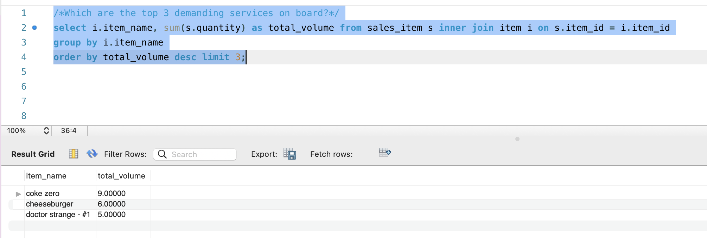

**Question 2:** Show the average number of tons of food & drinks needed per day.

**Script:**

*select s.sales_date_time, i.seg_name, (avg(i.weight)/1000) as average_food_beverages_in_tons from sales_item si, onboard_sales s,*

*(select i.item_id, i.item_name, i.weight, u.metric_name, c.cat_name, cl.class_name, f.fam_name, s.seg_name from item i, unit_measure u, category c, class cl, family f, segment s*

*where (i.unit_measure_id = u.unit_measure_id) and*

*(i.category_id = c.category_id) and*

*(c.class_id = cl.class_id) and*

*(cl.family_id = f.family_id) and*

*(f.segment_id = s.segment_id) and*

*(i.category_id in (*

*select category_id from category where class_id in (*

*select class_id from class where family_id in (*

*select family_id from family where family.segment_id = 1))))*

*group by i.item_id, i.item_name, i.weight, u.metric_name) i*

*where (si.sales_id = s.sales_id) and (si.item_id = i.item_id)*

*group by s.sales_date_time, i.seg_name;*

**Output result:**

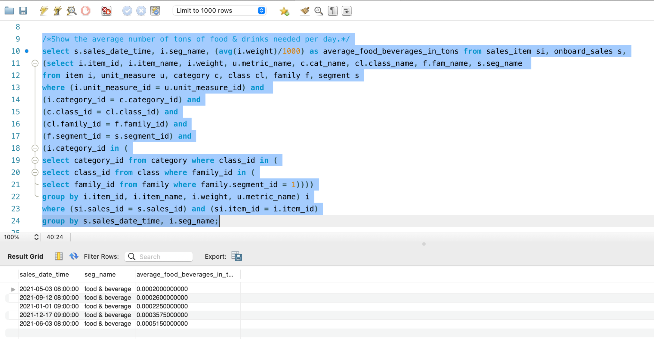

**Question 3**: How much money will be lost per day, if a ship is under repair?

In order to answer this question, we summed total revenue from tickets and onboard sales and calculated average revenue per day based on actual transaction days, i.e. total revenue divided by the number of days (actual days when transactions occurred).

The result is the average revenue per day and if the ship is in repair, this average revenue will be lost.

**Script:**

*select (sum(t.total) / count(t.revenue_date)) from*

*(*

*select t.date_time as revenue_date, c.currency_code, sum(t.total_order) as total from tickets t, currency c*

*where t.currency_id = c.currency_id*

*group by t.date_time, c.currency_code*

*union all*

*select s.sales_date_time as revenue_date, c.currency_code, sum(s.total_sales) as total from onboard_sales s, currency c*

*where s.currency_id = c.currency_id*

*group by s.sales_date_time, c.currency_code) t;*

**Output results:**

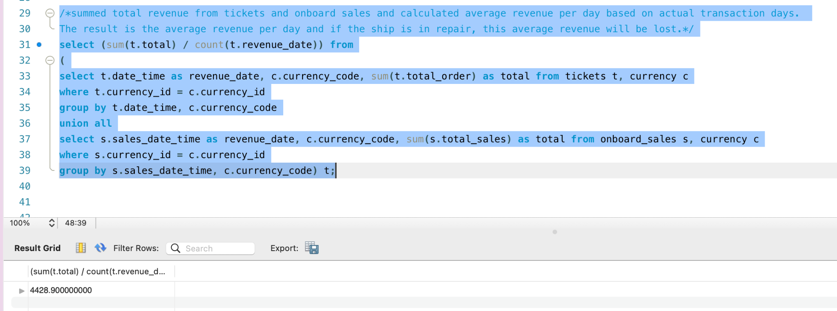

**Question 4**: Which is the most profitable cruise route (include season)?

Based on the business model our team built - the total revenue from the cruise consists of route price + price for room in a ship. Hence, to calculate the most profitable cruise, we took the total sales consisting of these two elements (routes + rooms).

**Script:**

*select se.route_name, se.season_name, c.currency_code, sum(t.total_order) as total_revenue from tickets t, currency c,*

*(select r.*, s.season_name from routes r, seasons s*

*where r.season_id = s.season_id) se*

*where t.route_id = se.route_id and t.currency_id = c.currency_id*

*group by se.route_name, se.season_name, c.currency_code*

*order by total_revenue desc*

*limit 1;*

**Output results:**

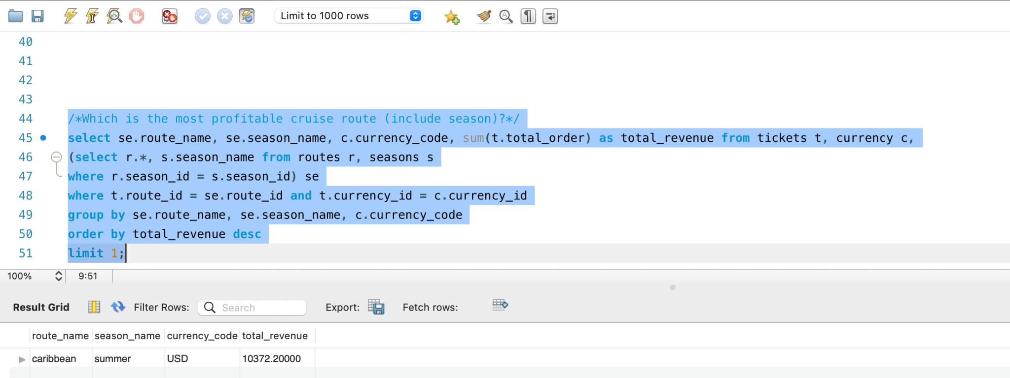

**Formatted queries:**

**Q1:**

***select***

***i.item_name,***

***sum(s.quantity) as total_volume***

***from sales_item s***

***inner join item i on s.item_id = i.item_id***

***group by i.item_name***

***order by total_volume desc limit 3;***

***Q2:***

***select***

***s.sales_date_time,***

***i.seg_name,***

***(avg(i.weight)/1000) as average_food_beverages_in_tons***

***from***

***sales_item si,***

***onboard_sales s,***

***(select i.item_id,***

***i.item_name,***

***i.weight,***

***u.metric_name,***

***s.seg_name***

***from item i,***

***unit_measure u,***

***category c,***

***class cl,***

***family f,***

***segment s***

***where (i.unit_measure_id = u.unit_measure_id) and***

***(i.category_id = c.category_id) and***

***(c.class_id = cl.class_id) and***

***(cl.family_id = f.family_id) and***

***(f.segment_id = s.segment_id) and***

***(i.category_id in***

***(***

***select category_id from category where class_id in***

***(***

***select class_id from class where family_id in (***

***select family_id from family where family.segment_id = 1)***

***)***

***)***

***)***

***group by i.item_id, i.item_name, i.weight, u.metric_name***

***) i***

***where (si.sales_id = s.sales_id) and (si.item_id = i.item_id)***

***group by s.sales_date_time, i.seg_name;***

***Q3:***

***select***

***(sum(t.total) / count(t.revenue_date))***

***from***

***(***

***select t.date_time as revenue_date,***

***c.currency_code,***

***sum(t.total_order) as total***

***from tickets t, currency c***

***where t.currency_id = c.currency_id***

***group by t.date_time, c.currency_code***

***union all***

***select s.sales_date_time as revenue_date,***

***c.currency_code,***

***sum(s.total_sales) as total***

***from onboard_sales s, currency c***

***where s.currency_id = c.currency_id***

***group by s.sales_date_time, c.currency_code***

***) t;***

***Q4:***

***select***

***se.route_name,***

***se.season_name,***

***c.currency_code,***

***sum(t.total_order) as total_revenue***

***from tickets t,***

***currency c,***

***(select r.*, s.season_name from routes r, seasons s***

***where r.season_id = s.season_id) se***

***where t.route_id = se.route_id and t.currency_id = c.currency_id***

***group by se.route_name, se.season_name, c.currency_code***

***order by total_revenue desc***

***limit 1;***